When “free” isn’t is launched

On 15 June 2016, eNACSO released When “Free” Isn't, a report which makes a strong case for improved policy, law and action to protect children against unfair and damaging business practices online.
The launch event was hosted by MEPs Anna Maria Corazza Bildt and Caterina Chinnici Co-Chairs of the Intergroup on Children’s Rights in the European Parliament.
The audience included a number of MEPs, MEP staff members, representatives from the European Commission, NGOs and self-regulatory organizations.

The Member of the European Parliament Anna Maria Corazza Bildt opened the conference by welcoming the participants.
Ms Corazza Bildt emphasized the importance of finding a proper balance between a child’s right to access information over the internet, their right to privacy and the right to be protected in the context of issues they could not be expected to understand. Common action at EU level is still necessary to live up to the new challenges and ensure better protection in terms of, for example, age verification.
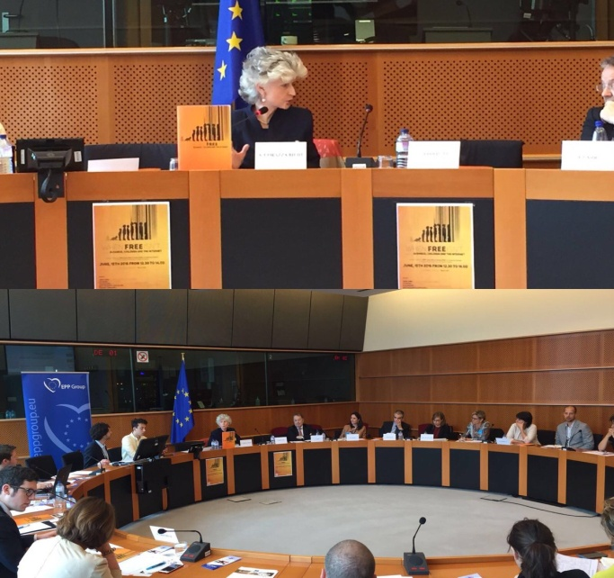
Ms Corazza Bildt highlighted some of the key points of the General Data Protection Regulation which had required specific attention, such as the rules for the processing of children’s data and underlined that it is her priority that children’s personal data online must be properly protected and that children need to be informed in an accessible manner about the risks and consequences of giving out their personal data online.
Moreover Ms Corazza Bildt reminded participants that we must treat children as rights holders and always put their best interests in the forefront of our work.

John Carr OBE, Advisor to eNACSO and co-author of the report, called for the Eu to adopt a radical approach by recognizing children and young people as economic actors in their own right.
He looked spoke about several of the key policy recommendations in When “Free” Isn't, for example calling for the EU to establish a charter of consumers’ rights for children, specifically recognizing their needs.
Children and young people are spending large amounts of money online and there’s a need to acknowledge this and recognise that children are a substantial group of consumers. If a business is willing to take money from a child it should accept it has a higher duty of care to that young person if anything goes wrong with the product or service or they need help.
There’s a need for the European Data Privacy Supervisor and the national Data Protection Authorities to take a greater interest in the position of children in an ecommerce setting and this has been made even more urgent by what has happened recently with the GDPR.

Dan Dionisie & Marthe H. Austgulen - DG Justice and Consumers presented the findings of the “Study on the impact of marketing through social media, online games and mobile applications on children's behavior“ recently published by a group of academics with support from the European Commission. It looked at a number of new and dynamic channels of online marketing to children, as well as some of the measures being taken to address consumer vulnerability among children. The study should help the Commission in preparing evidence-based proposals for new policy measures.

The project findings are summarized here.
See also the Executive Summary, Final Report, Fact Sheet and Infographic.

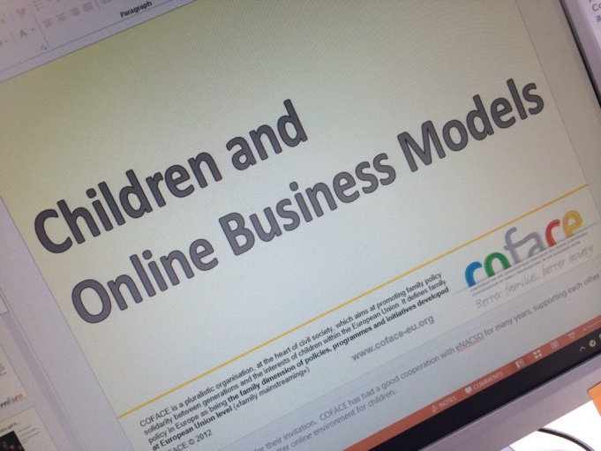
Ms Liz Gosme - Director of COFACE, outlined COFACE’s priorities with regard to child protection: there is a clear lack of transparency and information to users about the advertising based online business models, particularly in the area of “freemium” apps. How these work is obscure and misleading to an average user, and even more so to a child. According to COFACE there is a clear lack of clarity in respect of online advertising. While the industry will claim that online advertising is regulated by a mix of core regulation and self-regulation, COFACE has always pointed to its ineffectiveness.
Every time an online advertising practice falls under regulation or self-regulation, advertisers move towards more innovative advertising practices which are not covered under the existing schemes.
The General Data Protection Regulation (GDPR) includes a provision for more transparency and information to users but it’s implementation will determine whether it will make any difference for users or not.
The key recommendation from COFACE’s side is the need to develop standardized indicators to help users compare services/content providers between each other and get an insight into the business model.
Download COFACE ppt presentation here.

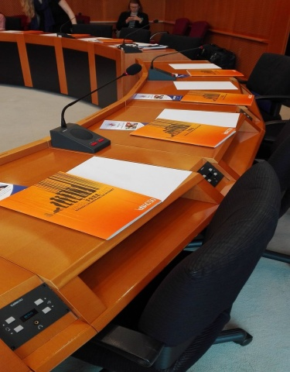
MEP Corazza Bildt welcomed the question from the floor which stressed the importance of improved measures in terms of rules and regulation to protect children from the effects of advertising and marketing online.
There was a widespread consensus that the EU needed to engage more energetically in the field of online child protection.

